**AIM:** To implement client-server model using socket programming using TCP (Transmission Control Protocol).

**PROGRAM CODE:**

**1] Server side- Run the exp3server.java first**

package exp3server;

import java.io.*;

import java.util.*;

import java.net.ServerSocket;

import java.net.Socket;

public class Exp3server{

public static void main(String[] args) throws Exception{

ServerSocket ss=new ServerSocket(2500);

while(true)

{

System.out.println("Waiting for request from client");

Socket so=ss.accept();

DataOutputStream out=new DataOutputStream(so.getOutputStream());

out.writeBytes("Date and Time of Server: " + (new Date()).toString() + "\n");

out.close();

so.close();

}

}

}

**2] Client side – Run the exp3client.java secondly.**

package exp3client;

import java.io.*;

import java.net.Socket;

import java.net.InetAddress;

public class Exp3client {

public static void main(String[] args)

throws Exception

{

Socket so=new Socket(InetAddress.getLocalHost(),2500);

BufferedReader in=new BufferedReader(new InputStreamReader(so.getInputStream() ));

System.out.println(in.readLine());

}

}

**OUTPUT:**

1] On executing exp3server.java

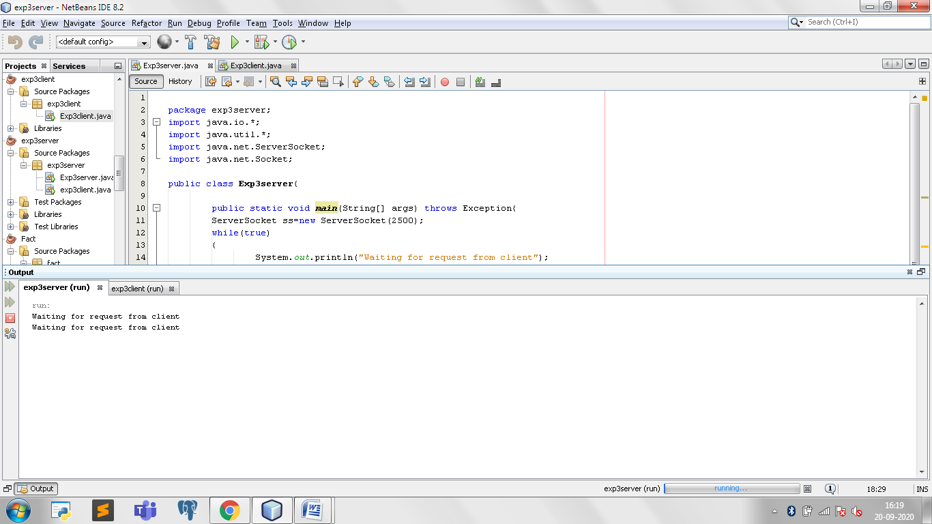

2] On executing exp3client.java

